Supporting data for use with Navigation Training video clips

Vector W/V:
Hdg(T) = 120; TAS = 100; Tk(T) = 105; GS = 80; Find the W/V

Vector Tk(T) and GS:
W/V = 030/20; Hdg(T) = 080; TAS = 110; Find the Tk(T) and GS

Vector Hdg(T) and GS:
W/V = 290/20; Tk(T) = 240; TAS = 105; Find Hdg(T) and GS

CRP-1 Distance and Time:
GS = 91; Distances (nm): 6, 11, 19, 5, 12, 7, 13, 20, 10; Total distance 103 nm

CRP-1 Hdg(T) and GS:
W/V = 290/20; Tk(T) = 240; TAS = 105; Find Hdg(T) and GS

CRP-1 Wind Velocity:
Hdg(T) = 140; TAS = 100; Tk(T) = 125; GS = 80; Find W/V

CRP-1 Altitude:
Indicated Altitude (ft) | Outside Air Temperature (ºC) | True Altitude (ft)
5,000 | +5 (ISA)  +15 – 10 = +5 | 5,000 (Accurate)
5,000 | +30 (ISA + 25)  +15 – 10 + 25 = +30 | 5,434 (Safe)
5,000 | -20 (ISA – 25)  +15 – 10 – 25 = –20 | 4,566 (Caution)

CRP-1 Fuel calculations:
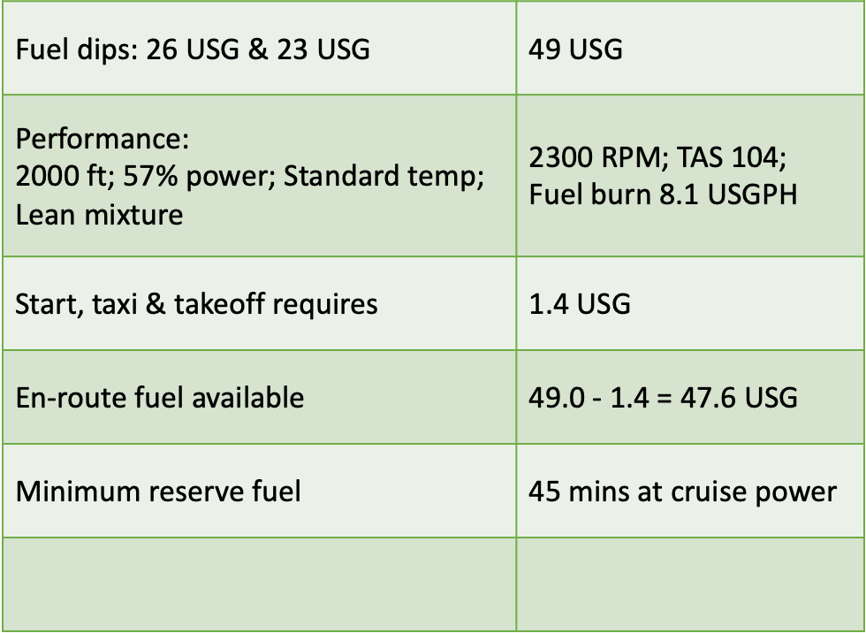
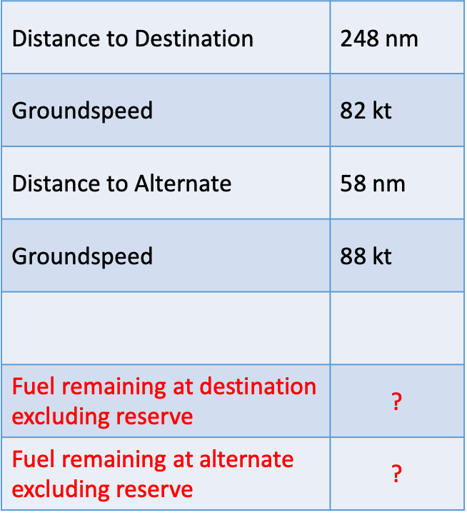

Cruise fuel in the tanks | 47.6 USG
Reduce by 45 mins reserve @ 8.1 USGPH | 6.1 USG
Destination & Alternate fuel available | 47.6 – 6.1 = 41.5 USG
41.5 USG @ 8.1 USGPH | 305 mins (307.4)
Time to destination: 248 nm @ 82 kt | 180 mins (181.5)
Fuel remaining at destination, excluding reserve | 305 – 180 = 125 mins
125 mins at 8.1 USGPH | 17 USG (16.87)
Time to alternate: 58 nm @ 88 kt | 40 mins (39.5)
Fuel remaining at alternate, excluding reserve | 125 – 40 = 85 mins
85 mins at 8.1 USGPH | 11.5 USG (11.47)
TOTAL fuel remaining on arriving at the Alternate | 11.5 USG + 6.1 USG reserve = 17.6 USG

