Navigation Charts

Navigation Charts are designed to be as useful as possible for the purpose of navigation.

There are three basic properties that are important as follows:
Conformality  (Orthomorphism) | Angles on the chart should be accurately presented in relation to those on the Earth’s surface.
Scale | The distance on the chart between one place and all other places should bear a constant ratio to the true distance on the Earth.
Equivalence | The presentation of area on the chart should be in correct proportion to that on the Earth.

The following considerations can also be taken into account:
Great Circle | As the shortest distance between two places on the Earth’s surface is along a Great Circle, it would be convenient to have Great Circles appearing as straight lines.
Rhumb Line | This is the path followed by an aircraft in flight maintaining a constant heading; therefore it would be convenient if this appeared as a straight line on a chart.

Properties of the Lambert Conformal Conic projection:
Conformality | The chart is made conformal by construction and therefore all angles and bearings are accurately portrayed.
Scale | Although scale varies slightly, contracting inside the standard parallels and expanding outside them, the scale over the whole chart can be taken, for all practical purposes, as constant.
Equivalence | The chart can be regarded as having the property of equal area. Therefore, the shapes of woods, lakes, etc will appear the same as on the Earth’s surface.
Great Circles | These can be considered to be straight lines on the chart.
Rhumb Lines | With the exception of the meridians, rhumb lines will appear as curves concave towards the nearer pole.

Properties of the Transverse Mercator projection:
Conformality | The chart is made conformal by construction and therefore all angles and bearings are accurately portrayed.
Scale | The scale is correct at the central meridian which is used as the datum. Either side of this, it expands; however due to the relatively small area covered on individual charts, the expansion is small.
Equivalence | Area becomes distorted either side of the datum meridian.
Great Circles | Although over large distances, Great Circles become complex curves; when small areas are involved, Great Circles are a close approximation to straight lines.
Rhumb Lines | These are curves concave to the nearer pole

Properties of the Direct Mercator projection:
Conformality | The chart is conformal so that all angles and bearings are accurately portrayed.
Scale | The scale expands away from the equator.
Equivalence | The chart can only be considered as having areas proportional to the Earth in the vicinity of the Equator. Area becomes increasingly distorted north and south of the Equator.
Great Circles | With the exception of the Equator and meridians of longitude, all great circles are curves concave to the equator.
Rhumb Lines | These are straight lines intersecting the meridians at their correct angle so bearings can be accurately measured.

Lambert Conformal Conic projection model:
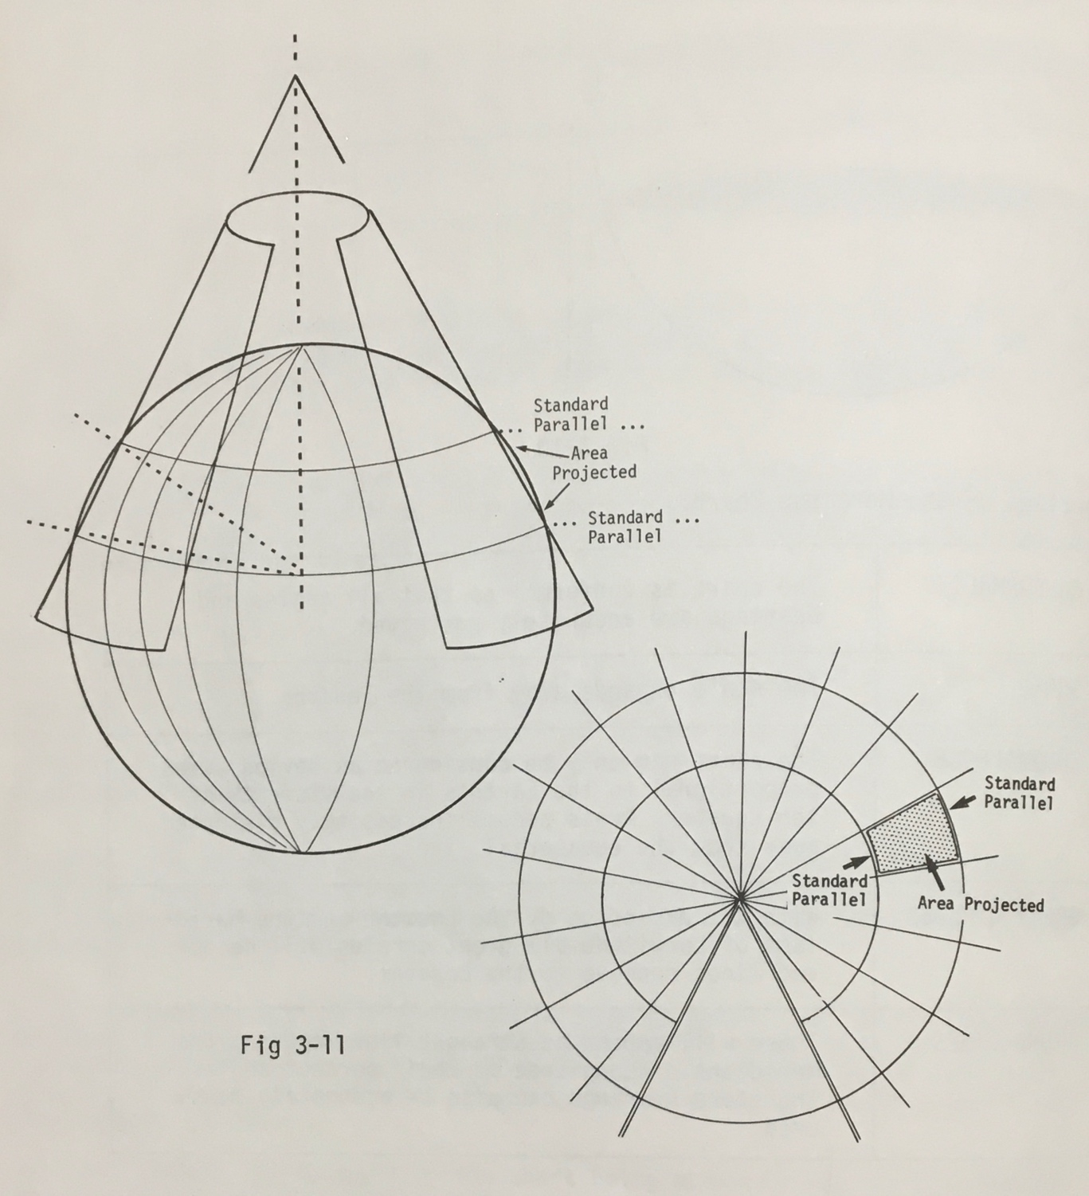

Transverse Mercator Projection model:

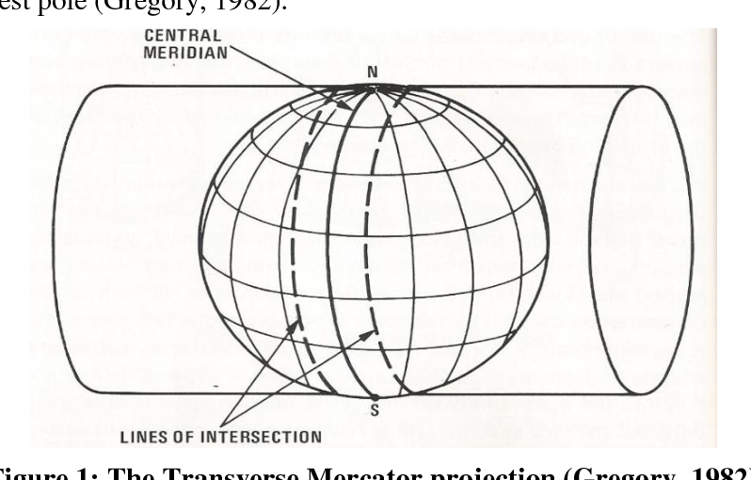

Direct Mercator Projection model:
